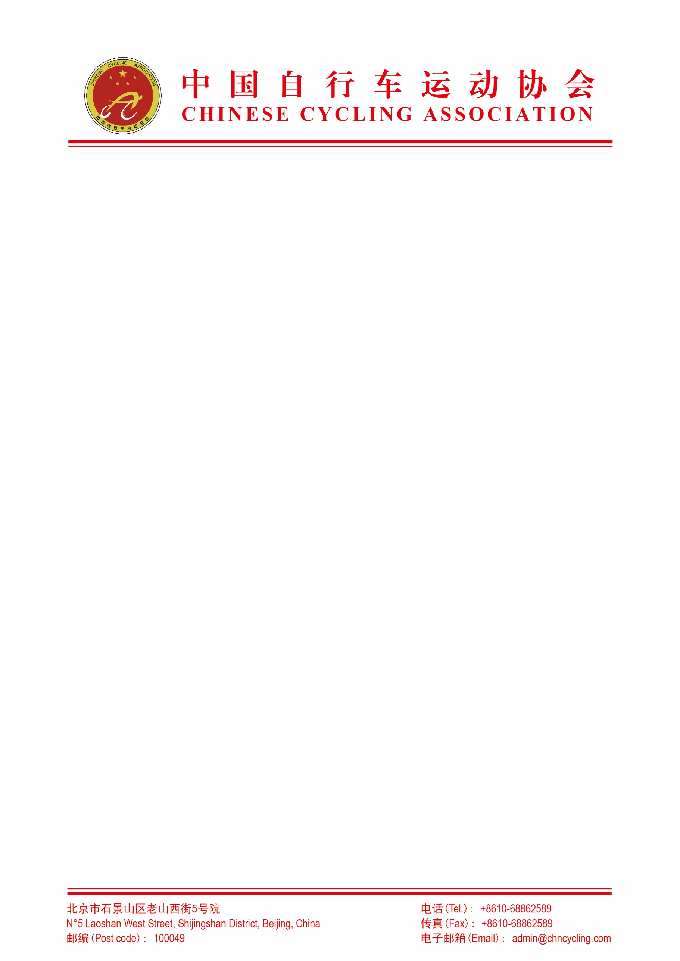

附件2

线上海选“选星计划”测试流程

本次选拔工作将通过线上测试的方式进行海选，选拔男子及女子运动员各3-5名，参加海南三亚的线下选拔训练营。在三亚选拔训练营通过选拔测试的优秀运动员，将有机会以预备队员的身份参加国家公路自行车队集训，或代表中国安踏mentech洲际队、中国喜德盛女子车队出征UCI国际比赛。
参加测试者需要完成以下测试内容并提交包含功率、心率、踏频在内的fit文件。提交测试文件时务必标注测试设备品牌型号，如SRM功率计、Polar H10心率带。
Test participants are required to complete the following test contents and submit a FIT file containing power, heart rate, and cadence. When submitting the test file, it is mandatory to mark the brand and model of the test equipment, such as SRM power meter and Polar H10 heart rate strap.
测试课程概述 Overview of Test Courses
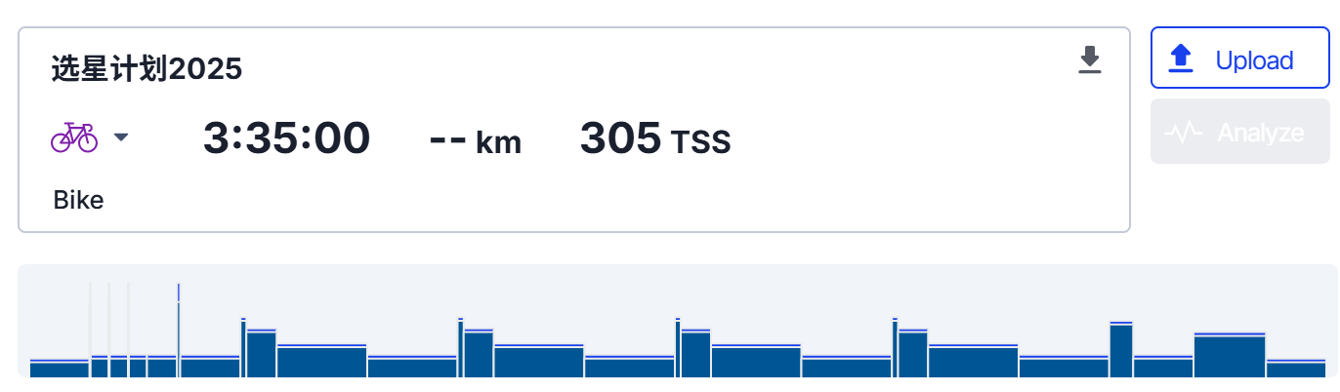

（1）热身模块Warm-up Module
10分钟自由骑行热身10-minute free riding warm-up
3组（10秒高踏频激活身体/3分钟恢复性自由骑行）3 sets of (10-second high-cadence riding to activate the body / 3-minute recovery free riding)
5分钟自由骑行5-minute free riding
（2）30秒测试30-Second Test
30秒冲刺，要求启动阶段争取达到最大功率，并全力维持直到30秒结束 A 30-second sprint,

Requiring to strive for maximum power during the start-up phase and maintain full effort until the end of the 30 seconds
（3）组间恢复，10分钟自由骑行Inter-set Recovery: 10-minute free riding
（4）抗疲劳测试Anti-Fatigue Test
男子测试选手按下面的功率输出要求不间断连续重复4次：（Male test participants shall continuously repeat the following power output requirements 4 times without interruption）
1分钟@7瓦/千克+5分钟@5.5瓦/千克+15分钟@4瓦/千克+15分钟@不限功率动态恢复（1min @ 7w/kg + 5min @ 5.5w/kg + 15min @ 4w/kg + 15min @ unlimited power dynamic recovery）
女子测试选手按下面的功率输出要求不间断连续重复4次：（Female test participants shall continuously repeat the following power output requirements 4 times without interruption）
1 分钟 @6 瓦 / 千克 + 5 分钟 @4.5 瓦 / 千克 + 15 分钟 @3.5 瓦 / 千克 + 15 分钟 @不限功率动态恢复（1min @ 6w/kg + 5min @ 4.5w/kg + 15min @ 3.5w/kg + 15min @ unlimited power dynamic recovery）
（5）4 分钟测试4-Minute Test
4 分钟全力骑行4-minute full-effort riding
（6）组间恢复，10 分钟自由骑行 Inter-set Recovery: 10-minute free riding
（7）12 分钟测试12-Minute Test
12 分钟全力骑行12-minute full-effort riding
（8）冷身恢复，10分钟自由骑行（Cool-down Recovery: 10-minute free riding）
测试说明Test Instructions
本测试共包含 8 个模块，请按照测试流程顺序依次完成，测试中使用码表每个模块分别计圈（例如，热身模块所有内容完成后按下 “计圈” 键→开始 “30 秒测试” 模块，30 秒全力输出结束后按下 “计圈” 键→进行 10 分钟自由骑行组间恢复）。
This test consists of 8 modules in total, which must be completed in the order of the test process. During the test, a stopwatch shall be used to lap each module separately (for example, press the "lap" button after completing all contents of the warm-up module → start the "30-Second Test" module; press the "lap" button after the end of the 30-second full-power output → conduct the
10-minute free riding inter-set recovery).
标红模块为记录测试成绩部分，共计 4 项：30 秒测试、抗疲劳测试、4 分钟测试、12 分钟测试。请务必严格按照标注的组间休息时间进行恢复，若休息时长大于规定时间，成绩作废。The red-marked modules are the parts for recording test results, totaling 4 items: 30-Second Test, Anti-Fatigue Test, 4-Minute Test, and 12-Minute Test. It is imperative to conduct recovery in strict accordance with the marked inter-set rest time; if the rest time exceeds the specified duration, the result will be invalid.
分数计算说明Score Calculation Instructions
（1）30秒测试、4 分钟测试、12 分钟测试按照赋分制打分，即根据全体测试者该项测试的结果（功率体重比瓦 / 千克）按照排名百分比进行赋分：The 30-Second Test, 4-Minute Test, and 12-Minute Test are scored based on a point assignment system, that is, scores are assigned according to the ranking percentage of all test participants' results (power-to-weight ratio in w/kg) in the respective test:
分数Score | 排名Ranking
100 | 5%
90 | 15%
80 | 25%
70 | 35%
60 | 45%
50 | 55%
40 | 65%
30 | 75%
20 | 85%
10 | 95%
0 | 100%

（2）抗疲劳测试共重复4次，每按照功率输出要求完成一次得25分；1min @ 7w/kg（女子6w/kg）计5分、5min @ 5.5w/kg（女子4.5w/kg）计10分、15min @ 4w/kg（女子3.5w/kg）计10分。
The Anti-Fatigue Test is repeated 4 times in total, and 25 points are awarded for each complete completion in accordance with the power output requirements; 5 points are awarded for 1min @ 7w/kg (6w/kg for females), 10 points for 5min @ 5.5w/kg (4.5w/kg for females), and 10 points for 15min @ 4w/kg (3.5w/kg for females).
例如某男性测试者抗疲劳测试按功率要求完成了完整的3次，第4次只有1min @ 7w/kg达到了目标功率，则该测试项目得分为：3 x 25 + 5 = 80分。
For example, if a male test participant completes the Anti-Fatigue Test 3 times in full accordance with the power requirements, and only achieves the target power for 1min @ 7w/kg in the 4th time, the score for this test item is: 3×25 + 5 = 80 points.
（3）最终入围成绩按照所有项目得分累加计算。
The final score is calculated by summing up the scores of all items.
联系方式
参加选拔的运动员请将报名表与测试数据（Fit文件）于11月30日前以电子邮件形式报送。
邮箱：antamentech@163.com （邮件标题：自行车测试 姓名×××，请报名表与测试数据添加在邮件附件中）
联系方式：
王宇航 13857153656 电话/微信

